Redis Cache

https://www.geeksforgeeks.org/advance-java/spring-boot-caching-with-redis/

Actually redis Cache manager configuration is missed in the above tutorial, so I added that configuration in the config folder, do check the code.

Then refer the code in the github

Start the application, check the DB whether tables are created o not
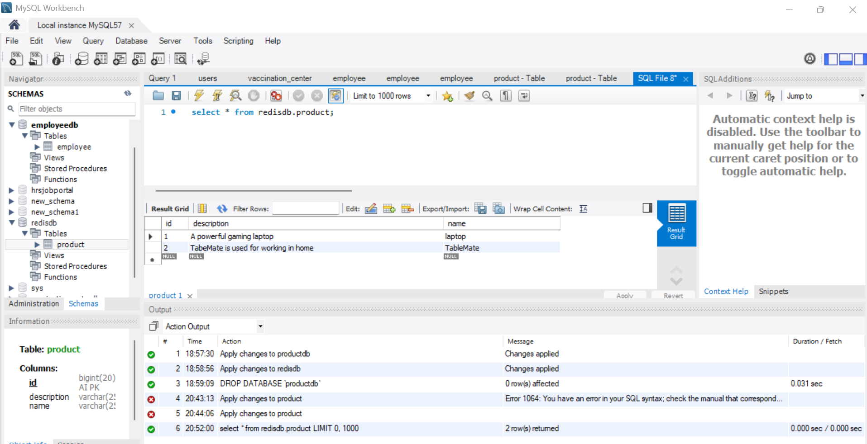

Then hit the API in postMan

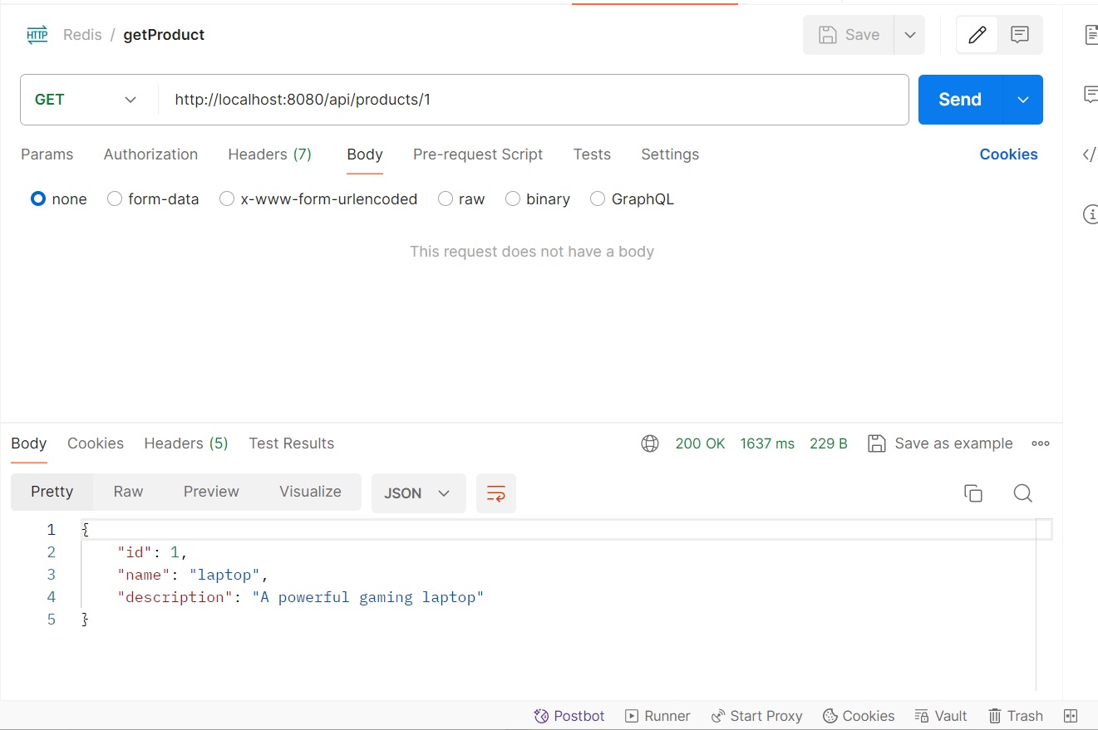

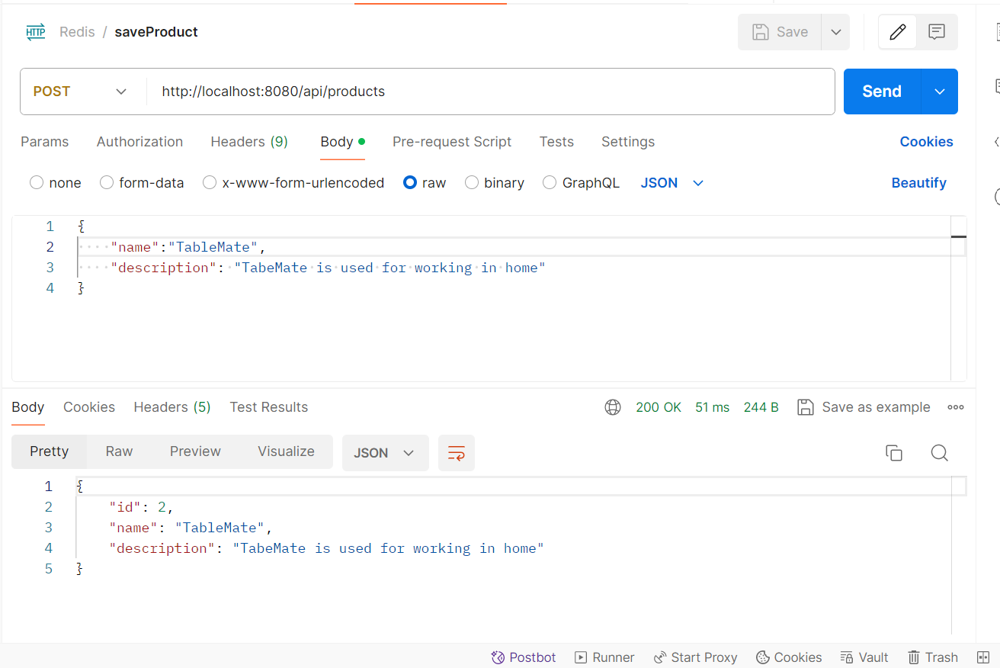

Then run the docker commands in normal cli

docker pull redis/redis-stack:latest

docker run -d --name redis-stack -p 6379:6379 -p 8001:8001 redis/redis-stack:latest

docker exec -it redis-stack redis-cli

ping

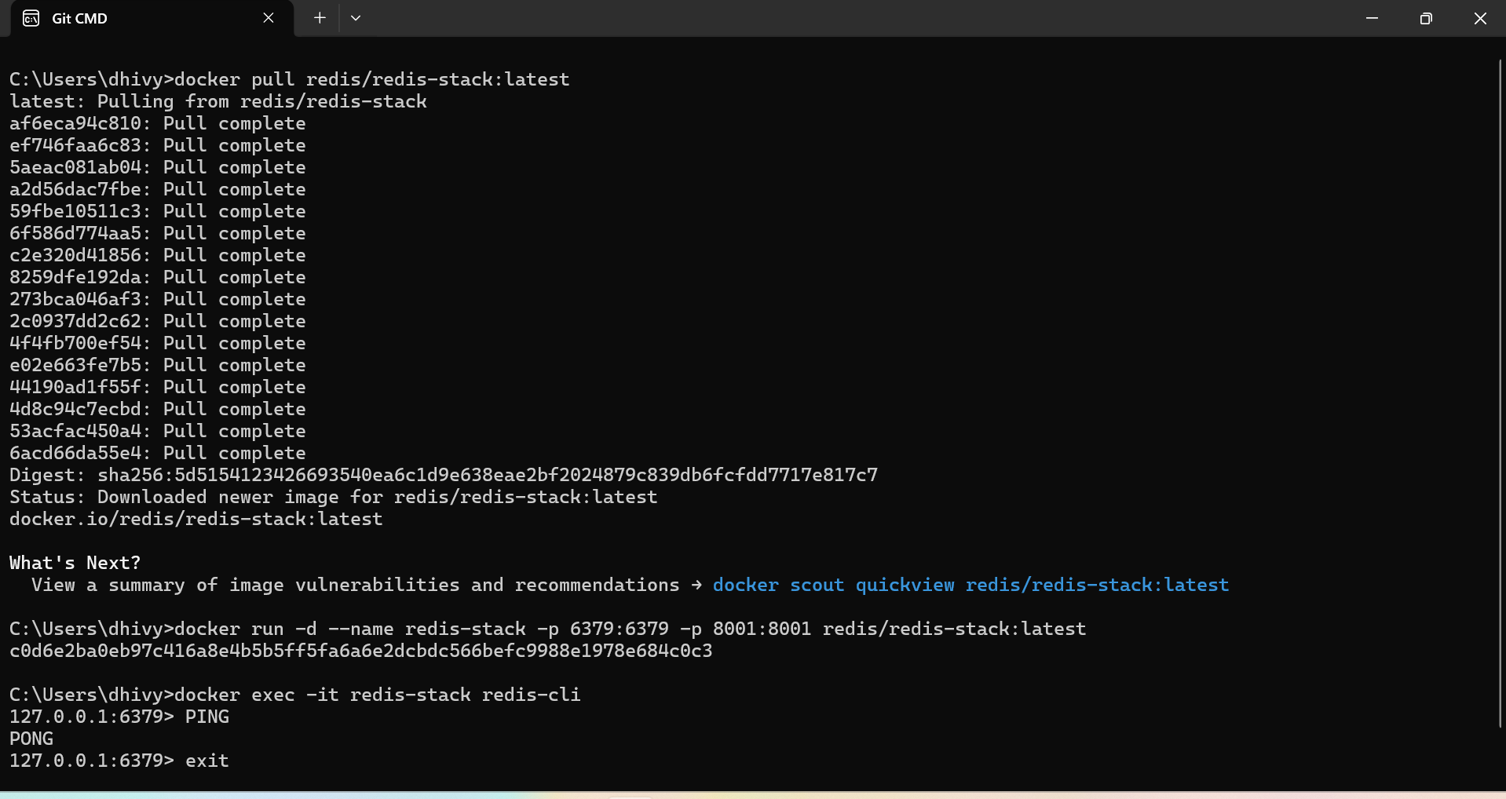

Then load the redisCache dashboard

http://localhost:8001

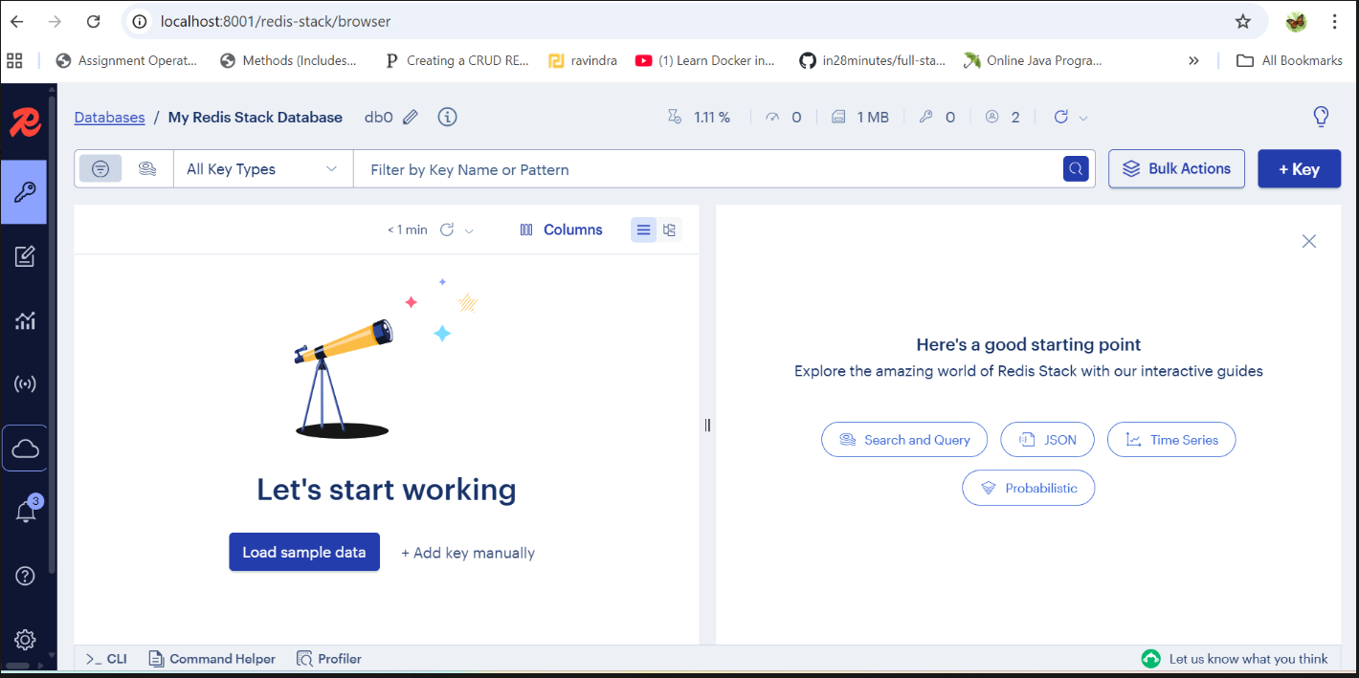

Then again hit the GET api, to have a data in a cache
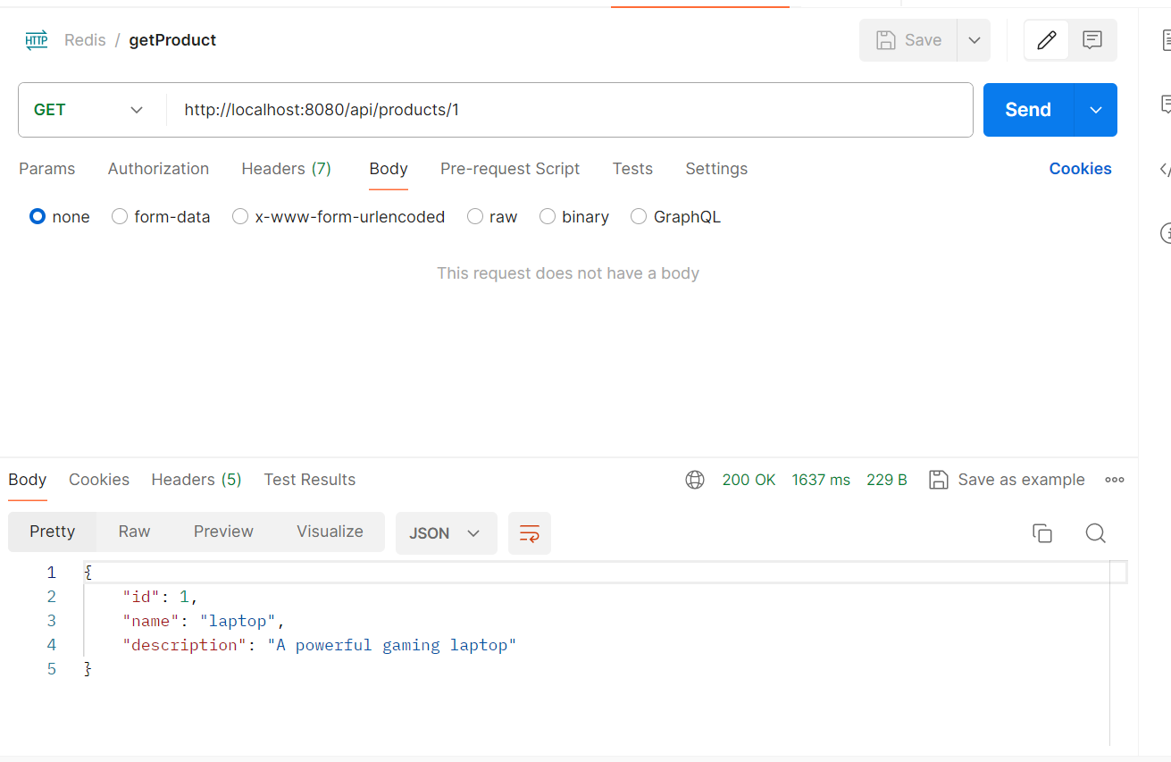

Then will able to see the keys in Redis cache

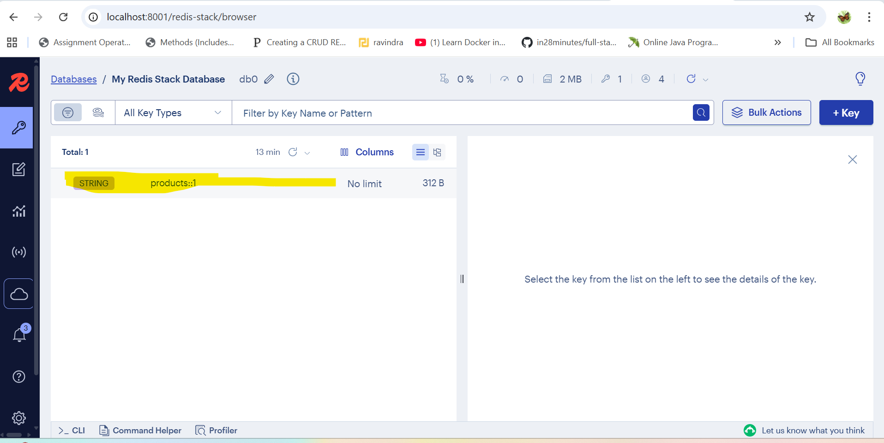

Redis Cache Implemented

Happy learning

